
School of Engineering

Introduction to AIML
Assignment-1
Week-3 Report
Development & Implementation

Submitted by
Thanushree G M
24UG00562
CS-AI
‘B’- section

Introduction
In week 3, the main focus was on developing the main functions of the campus navigation system. This contained implementing the parts that handle user queries and questions about the campus and finding the best routes between the buildings. A database was connected to store some basic campus information such as facilities. This supports user queries and navigation.

Objectives

- To implement the core modules of a campus navigation system that could answer questions regarding campus facilities.

- To model the campus as a graph to enable efficient pathfinding from one building to another.

- To implement search algorithms for discovering the shortest paths on campus.

- To integrate the system with a database to enable in-depth staff and facility information.

System Overview

The system consists of main 3 parts:
- Databased module- which stores some basic information about campus buildings, paths.
- Navigation module-finds the best route between the buildings.
- Query handling module- Answers the user questions/ queries using the stored data.

Testing and Observations

The system was tested through input of multiple sample queries involving campus FAQs as well as navigation requests. The responses for FAQs were checked in stored data. The navigation tests included determining routes between start and goal point to see whether the pathfinding algorithms provided correct and reasonable routes. The database connection was also tested to verify correct retrieval facility information.

UCS Output
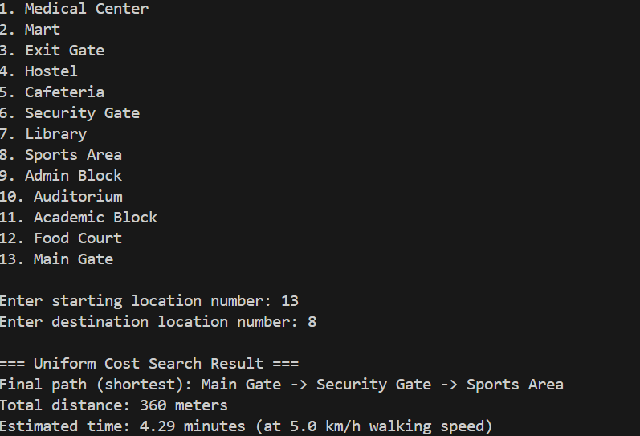

A* Output
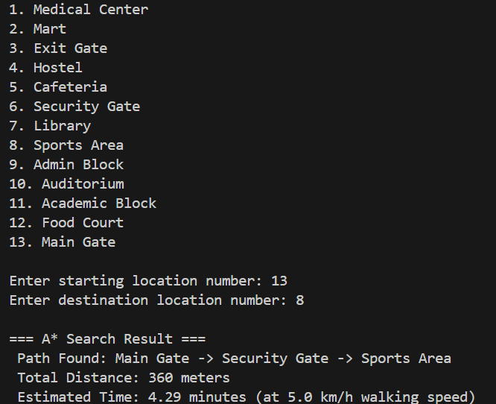

BFS Output
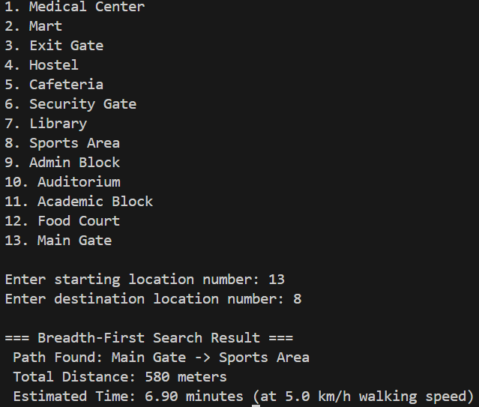

DFS Output
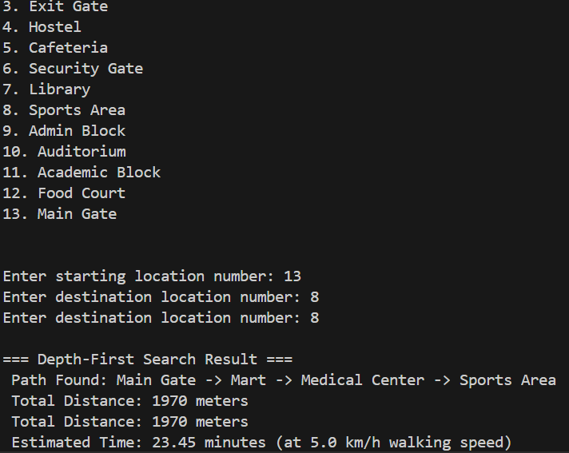
We can conclude from the above outputs of the 4 algorithms by saying UCS and A* gives the shortest distance but BFS gives more distance compared to them, DFS gives the longest distance.

